
A10
Sreenidhi Institute of Science and Technology
(An Autonomous Institution)
Code No: 101IT02/111IT02
B. TECH. II-Year I-Semester Examinations, December 2015 (Supplementary)
MATHEMATICAL FOUNDATIONS OF COMPUTER SCIENCE (CSE & IT)

Time: 3 Hours Max. Marks: 70

Note: No additional answer sheets will be provided.

Part - A
Max.Marks:20

Answer all QUESTIONS. EACH QUESTION CARRIES 2 MARKS.

- Construct the truth table for 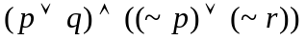.
- What is the Hasse Diagram?
- Define recursive function and give an example.
- Define Monoid and give an example.
- The results of 50 foot ball games (win, lose or tie) are to be predicted. How many
different forecasts can contain exactly 28 correct results.
- What is the principle of inclusion-exclusion?
- Let 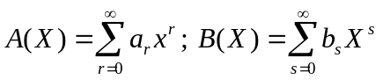be two formal series, then define the following :
  - Equality (b) Sum (c) Product (d) Multiplication by a scalar number
- Define the following :
  - Recurrence relation (b) Homogeneous relation
- Define Isomorphic graph.
- Define k- chromatic

Part – B
Max.Marks:50

ANSWER ANY FIVE QUESTIONS. EACH QUESTION CARRIES 10 MARKS.

1 (a) Construct the proof by contradiction. [3M]

(b) Suppose that the 10 integers 1,2,…, 10 are randomly positioned around a circular wheel.
Show that the some set of number 3 consecutively positioned numbers is at least 17. [7M]

2 (a) Explain the properties of the binary relations. [5M]

(b) Which of the properties of the binary relations must apply to every subgraph of a die graph if
it applies to the whole graph. [5M]

3 (a) Define isomorphic function and give an example. [3M]

(b) Let (S, *) and (T,  be monoids with identites e and , respectively. Let 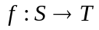be an
isomorphism. Then prove that 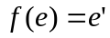. [7M]

4 (a) Enumerate the number of non-negative integral solutions to the inequality
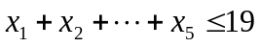 . [5M]

(b) A telegraph can transmit two different signals : a dot and a dash. What length of
these symbols is needed to encode the 26 letters of the English alphabets and the
ten digits 0 to 9. [5M]

5 (a) Define geometric series. [3M]

(b) Compute the coefficients of 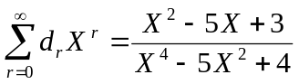 [7M]

6 Solve the recurrence relation 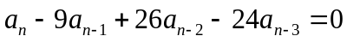 for 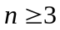

7 (a) State and prove Euler’s formula . [5M]

(b) Show that a complete bipartite graph 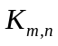 is planar iff 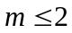 or 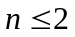. [5M]

8 (a) State and prove Grinberg’s theorem. [7M]

(b) Use Grinberg’s theorem to show that there is no planar Hamiltonian graph with regions of
degree 5, 8 and 9 with exactly one region of degree 9. [3M]

-- 00 -- 00 --

